**Explanation of Visualization**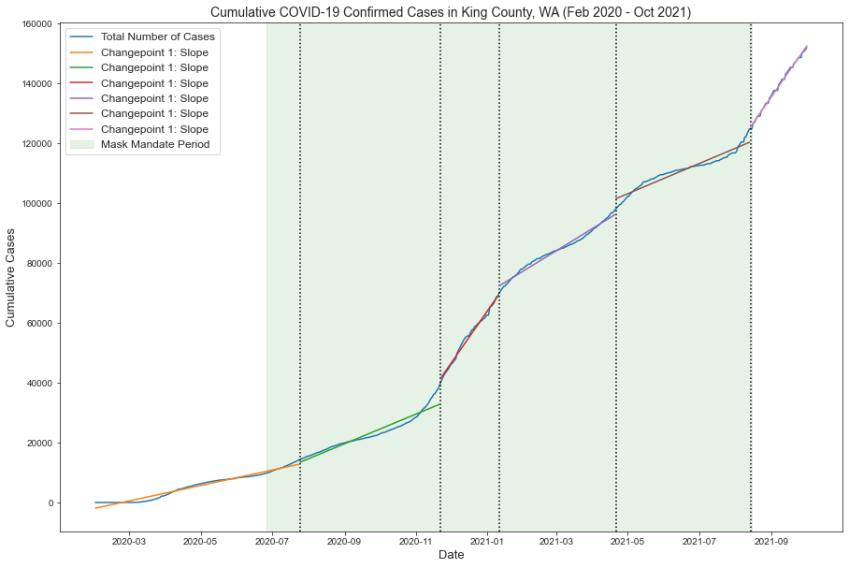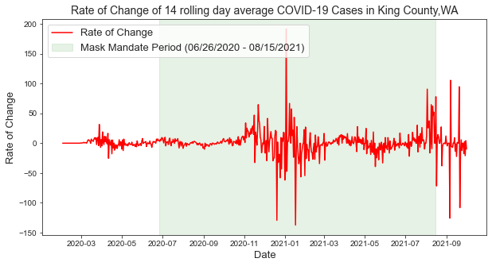

There are two different visualizations. One visualization, `Cumulative COVID-19 Confirmed Cases (Feb 2020 - Oct 2021)`, represents the trend cumulative sum of cases in King Country with its respective changepoints (characterized by the dotted lines) and derivative function (slope) by date. Each change point, which was calculated using the `ruptures` library, represents portions or dates that have similar statistical characteristics, and can represent a higher change in COVID-19 case growth. However, we can analyze the various slopes of the derivative function of each changepoint. The slopes can interpret the rate at which COVID-19 cases grew over a specific amount of time. Before the masking mandate, there was a slight increase in cases, however, this represents the start of COVID-19 in the area. In implementing masking mandates, we don't see results right from the start due to delays in testing. However, the masking mandate does seem to lower the rate of growth (a less steep slope) that is shown in the second, fourth, and fifth changepoint. There is a high increase in cases around the end of 2020 and the beginning of 2021. This can be due to a potential backlog of testing that was received before the holidays and tested all within the span of a week. One thing to note is that King County, WA is highly populated within a small area- thus, we can assume little effect from the masking policy to the number of cases and should probably analyze the trend over more months and after the true mask mandate ended.  
  
The second visualization `Rate of Change of 14 rolling day average` shows the rate of change between the daily average. You can see if the average 14 day rolling average jumped or lowered and if there’s a specific pattern. Here, we see the largest jump that occurs in the beginning of 2021, which can be due to the reasons stated beforehand. However, before this giant spike we see quite small rates of change, which can indicate consistent testing procedures or less variance in reported cases daily. After we see this jump, we have a small pattern in decreasing averages. However, in both graphs, it looks as if masking protocols alone did not help COVID-19 cases.

**Reflection**

Since many of us had different counties, it was interesting to see the various trends specific people have. All our results were unique. Many people had varying questions when it came to what the best way was to represent the data and answer the overall question. There was also sharing of different methods, python libraries, and packages that can help guide and form the analysis. What was most helpful was getting the insight of a few peers to interpret what my visualizations meant, to gauge if the visualizations made sense, if the visualization added value to the context of the analysis, or if it was even necessary to implement. I utilized the changepoint concept that was brought up in the class chat, but with a different library ruptures. (Others used packages like Facebook prophet). To implement ruptures, I followed the documentation here: <https://github.com/deepcharles/ruptures>. What was interesting was that another classmate also utilized the same library and shared his code with the class after I have done my analysis as well, although, I did not share the package in the chat. We had very similar outputs. I decided to go along finding the various changes in growth rate within the changepoints to see which period of time had the fastest rate and then the lowest rate. The collaboration amongst the whole class was insightful, however, I feel like due to the different times we did work on the assignment, efficient collaboration amongst us all will be hard to achieve. I also believe a more cohesive analysis could be done if there was more time to figure out the best way to answer the question, which would possibly need more data (ideally, actual mask usage). What also helped me was when I found instances in my raw data files where it seemed as if more recent dates had lower cases from previous dates, which should not be the case as the values should be cumulative. After discussion with a few classmates, I found the best way to correct this issue was to linear interpolate the number of cases for these points. Other things that were discussed was how to implement the results from the mask usage survey from the New York time. This was difficult to see due to the results of this project only being a proportion value that indicated how often people would utilize this survey. Some only marked the period of mask usage on their graph- I decided not to incorporate into the analysis, although, it does seem as if most of King County’s surveyed individuals are more on the side of utilizing masks than not.